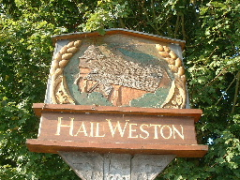

HAIL WESTON PARISH COUNCIL INVITE ALL RESIDENTS TO ATTEND THE

ANNUAL ‘PARISH ASSEMBLY’ OPEN MEETING

Held in the village hall

Refreshments will be offered at the meeting

TUESDAY 19 MARCH 2024 at 7.30 pm

MEET YOUR PARISH COUNCILLORS, HEAR ABOUT……ITS WORK, AND DISTRICT MATTERS.
TELL US…... ANYTHING AT ALL CONCERNING YOUR VILLAGE.

UPDATES FROM: - VILLAGE GROUPS, CHAIRMAN REPORT, REPORTS FROM DISTRICT COUNCILLOR & SOLAR PLANNING

We hope to see you soon.

